Issue 2 Friday evening

Bozo Bus Tribune

T h e O f f i c i a l O r g a n o f M i n i c o n 5 3
“ W e ' r e a l l b o z o s o n t h i s b u s ! ”

Is this the pedantic one, or isn't it?
This convention's theme is “The Pedantic One,” but your editor has yet to see any real pedantry! (Well, until a discussion of significant digits and tape measures took place as he was writing this piece... but the sentiment still counts.) This must not stand! This publication calls on you to submit your favorite examples of pedantry to the BBT for publication in a future issue. Drown us in pointless corrections and “Well, actually”s!

If you'd like to pay your respects
There will be a memorial event for the fen lost over the past year, including Rob Ihinger, Sarah Prince and Marian Turner, in the Consuite at 11p.m. Friday.

Or if you feel less respectful...
From Crystal T. on Facebook: "Totes Innapropes: The Terrible Party in room 329 will have terrible card games (like Joking Hazard), sweary coloring books, and wine." Sounds like a time!

Looking for parking?
According to hotel liaison Aaron Van Der Giessen, there is more available parking on the back side of the hotel, between the building and the strip mall full of restaurants. To get there, head for the lobby, but turn left rather than right to leave the hotel. Also note that the orange cones denote “accessible parking” for those with mobility challenges.

Looking for Magic?
The Crappy Magic Card Draft will be held at 8:30 Saturday night—not Friday as listed in the program book.
Looking to eat out?
“Just back from the lunch buffet at Taste of India. It is lovely, with a large variety of flavors, good vegetarian options, and range of spicing. Been going to this restaurant for years and this is better than it has been for a while. A good deal for $14.”
-Lydy Nickerson
John W. adds that while they have many of the expected North Indian dishes, they have a large selection of Indochinese dishes and plan to have more South Indian options tomorrow. Watch out for the level of cardamom in the Chai Masala!

Or if you'd rather eat in...
Brittney Harvin, Communications Coordinator for the DoubleTree, wants to let Minicon know about the weekend lunch and dinner specials available at the hotel's own Dover Restaurant & Bar. With names like “Zeppelins vs. Blimps” and “The Dodo,” you can tell they're trying. :-) The menu is available at the restaurant and on the Minicon Facebook group.

And don't forget brunch!
The hotel is offering an Easter Brunch in the poolside atrium. The downside? This is what we know as the gaming area, which means gamers will have to move to the overflow mezzanine Sunday morning. The upside is that it's open to the public ($22 for adults, $18 seniors, $15 children 5-12) and it looks delicious! Chicken and waffles... pickled eggs... salted caramel apple bread... omelets made to order... carved prime rib with horseradish and au jus? Yeah, maybe worth doing.

It's that time of year again
Tiangong-1 is still aloft, but the International Space Station can be seen flying overhead each night, starting at 10:42 Friday night. Come to the Science Room for the details.
Film Room: Flora Star Q&A!
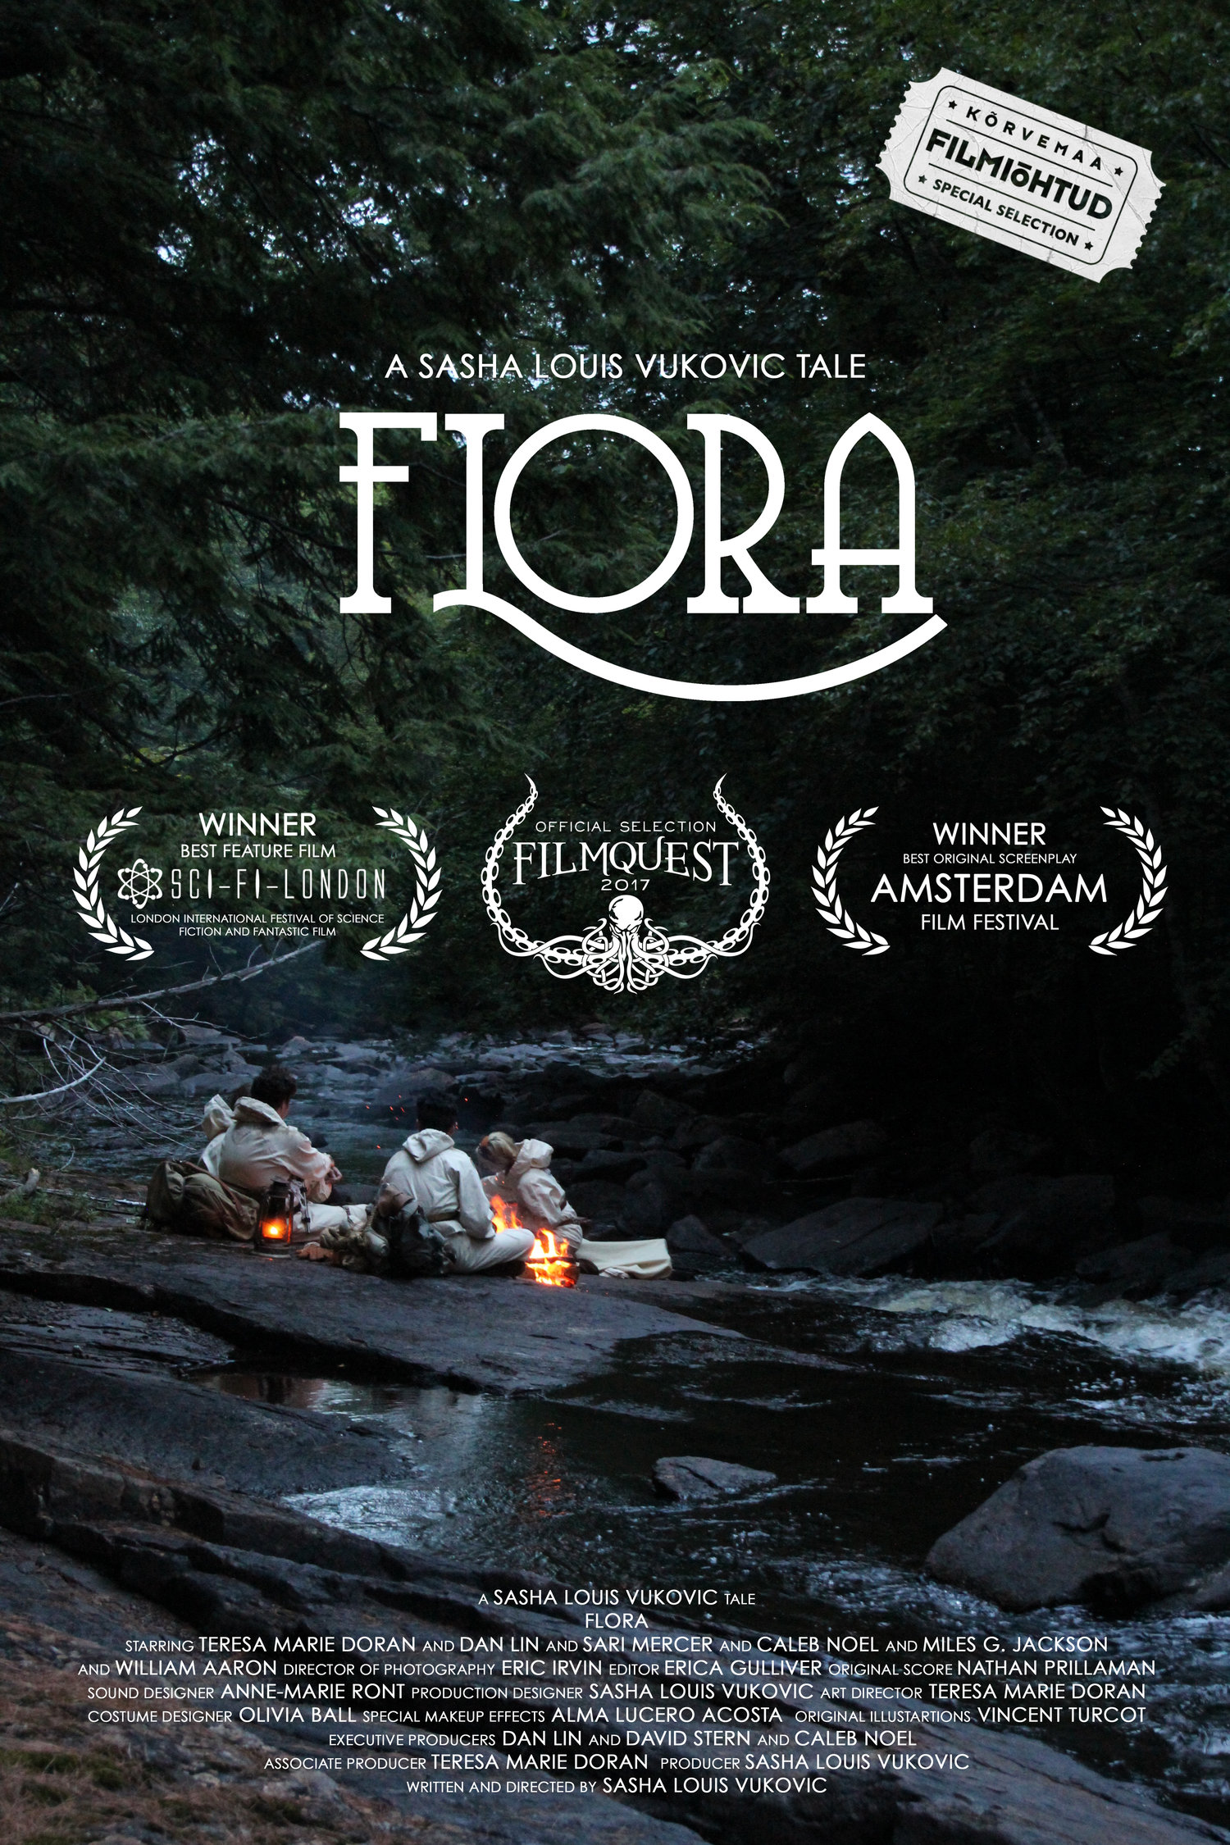
Teresa Marie Doran, an actress born and raised in Saint Paul, has acted in local live theater (Walking Shadow Theatre Company, The Children's Theatre Company, The Public Theater of Minnesota), and plays Ora Blackwood in Flora, an independent 2017 movie from Canada. Teresa is attending Minicon 53 and will host a Q&A session following the screening of Flora, scheduled for 1:45p.m. Saturday.
Her character is the botanical illustrator for a scientific expedition in 1929. On track to become the first graduated female botanist in the country, she has a passion for early science fiction, H.G. Wells and Jules Verne. Come say hello to Teresa and view her recent film, which has been garnering awards and nominations at several film festivals.
-Michael Kingsley

Condolences to Becca Leathers, who threw out her back yesterday and had to visit the ER. She was unable to play with Riverfolk and may not be able to attend. :-(

Medallion Hunt =TRISKAI=
I continue to be honored to serve as the Cluemeister and welcome you back to the Annual Minicon Medallion Hunt, round 13—as Triskai as I can make it! For those who just boarded the Bozo Bus, the Medallion Hunt is a treasure hunt for shiny 1973 pennies squirreled away throughout the hotel. Once found, please bring your penny to me (J), the Cluemeister, & exchange it for a prize from the BBT Office, located in the Spring Room on the first floor, and a healthy dose of pride with a side order of gloating. The office is open during the day, during Hours of Redemption, (posted in the BBT), and at other times as advertised outside of the BBT Office. As an additional hunting aid, there will be a sign outside the BBT Office tracking the status of the various medallions. You'll also get the saga of your quest published for all to see in the next issue.
The clues can be anything from straightforward obfuscation, to puns, codes or puzzles that involve math, science, pop culture references, or pretty much anything else the Dungeon Master, I mean Game Keeper, uh... Cluemeister contrives.
As in past years, all pennies have been hidden in public places within the hotel, but not within restrooms, shops, or anywhere in the Art/Dealers or Science Room. All pennies will be generally accessible each day. This year the pennies are unmarked, but all medallions except for #’s 15 & 20 (The Big Kahuna) have a small white paper tag next to them with their number. When found, please bring this tag, but leave at least one of the two pieces of blue tape in place to signal to other seekers that a penny was there. The big Kahuna will earn a prize from a premium set.
Please be respectful and quiet when searching outside of convention space. Take care when searching not to disturb hotel guests or set off any emergency alarms. We’re all Bozos on this bus and once you’re on you’re... “One Of Us”... “One Of Us”... “One Of Us”!
-The Cluemeister

/=\=/=\=/=\=/=\=/=\=/=\=/=\=/=\=/=\/=\=/=\=/=\=/=\=/=\=/=\=/=\=/=\=/
C L U E S : R O U N D 1
1. Where the wild things are
2. I lower enthalpy, I’m very American, I give & I give, I get nothing back
3. Many will pass in front of me but none will see me. I witness a lot of busyness but not much labor
4. I’m sitting near-ish to the center of the function space, many will pass me, some won’t be able to
5. Many pass by me on their way somewhere or other. Lincoln’s getting a head-rush while I hold on tight
6. Something old, something new, something borrowed. You probably won’t need me but if you do, you’ll be happy I’m here.
7. You can’t get in without permission, I can’t give you anything unexpected
8. You don’t want to hear from me, if you do, there’ll be no mistaking it
9. I’m always available. Finding me has more to offer than just a medallion. A toast to your health
10. Cons exist by give & take. Every member contributes, some more than others.
15. Something old, something new, something borrowed. If you use your eyes you’ll see I’m not chicken. I’ve come a long way to meet you and bring you home.
20. It will not be visible. You may have to meet someone new, or someone “new to you.” This unique hiding place was chosen to encourage social connection between con members. This location is one: which very little light can reach, it cannot speak nor taste.

Have an announcement, a news story, a review, a personal item, or anything else for the BBT? Drop it in the Submission Box outside the BBT Office or write to bbt@minicon53.mnstf.org.
====================================================

The Bozo Bus Tribune
Volume 53, Issue 2
Editor – Thorin N. Tatge
Reporter – Sharon E. Kahn
Cluemeister – J
© 2018 by the Minnesota Science Fiction Society. Any opinions expressed herein are those of the contributors, not necessarily anyone else's.

