Issue 3 Saturday afternoon

Bozo Bus Tribune

T h e O f f i c i a l O r g a n o f M i n i c o n 5 3
“ W e ' r e a l l b o z o s o n t h i s b u s ! ”

Searching for Chuck Tingle...
Theories were broad, numerous and easily abandoned at the “I am not Chuck Tingle” panel (8:30 Fri). Does or does not Mark Oshiro know? The evidence was weighed. One audience member proposed that Mr. Tingle is someone fandom-adjacent: "I believe all of us are like two or three degrees of separation from—"
"Oh, it's Kevin Bacon," concluded Rachel Swirsky. She later revealed the reason she can't write porn: everything might be going fine and then "Oh no, there's plot, and now everyone's dying and it's just sad."
Rick Snyder suggested that "Chuck Tingle" might be a mantle or title, similar to the Dread Pirate Roberts, an idea which won some acclaim. Will every writer eventually get a turn?
Or could it be George R. R. Martin trolling impatient fans? "The more you demand the next novel... the more I'm gonna get plowed in the butt."

Minicon milestone
“Insanity. That's Bonnie Somdahl's secret. The secret to running the Rumpus Room. This year marks Bonnie's seventh consecutive year in charge of Minicon's kids' programming. She's now the longest serving head of kids' programming, moving past Marian Turner, who was in charge for six consecutive conventions. So, swing by the Rumpus Room to pay your respects to the Queen of Insanity. You might even join in the fun if you dare to approach the box fort (shield optional, but encouraged), watch a puppet show, or observe one of the many amazing activities offered. Huzzah Bonnie!
“For a blog post about this year's Rumpus Room after the convention, visit RandyHaaland.com.”
-Randy Haaland
Conlanging documentary
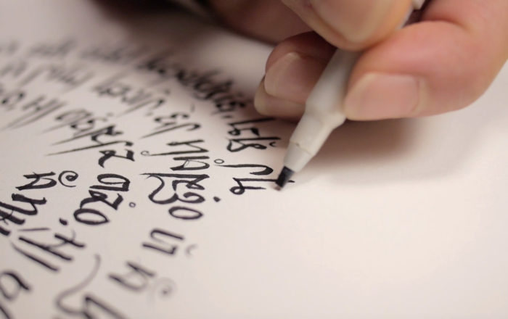
With language becoming an important detail in world-building for fantasy, science fiction, and other entertainment genres, the art of language construction is currently undergoing a renaissance in popular culture. Conlanging: The Art Of Crafting Tongues is
the first
feature documentary about the global phenomenon of constructed languages and the people who invent them. Such invented languages include Na'vi from the film Avatar, Dothraki from Game of Thrones and Kryptonian from Man of Steel, as well as the elven languages from Tolkien. This documentary is scheduled for noon Sunday at Cinema Obscura (Terrace 4).
-Michael Kingsley

It's not a marshmallow world in the winter
“It was too windy and cold to get the marshmallows to burn today. So—Monster Immolation is moved to Sunday at 11:30.”
-Rumpus Room

Sketch the Con
Explore our new space and the people in it
Saturday, 4pm in the lobby
Art supplies available.
Meet back up at 9pm To share your sketches.
What's your favorite piece of pedantry?
Hybrid teas, meaning roses, are not the same as tea roses! Hybrids are cultivated from both Chinese and European stock and can survive in a harsh winter climate... unlike classic tea roses.
“Submission box” should not be capitalized. [Ed: We proper-nouned it! That thing is baptized!]
That's my secret, Cap—I'm ALWAYS pedantic!
-Bill Higgins

A reminder for gamers
Remember—the lower atrium is needed for tomorrow's Brunch! We have to be out of there by 5.a.m. Sunday... but it will be easier if gamers, as they finish their games, move a few boxes up the stairs to the overflow gaming mezzanine. Please?

Highlights from Opening Ceremonies
- While there may not currently be 100 people having their own impromptu convention at our old hotel, chair Emily Stewart reports that the Old Dutch chip delivery did originally go there by mistake. “If they can find their way here, so can anyone.”
- Lyda Morehouse took a minute to argue with her own alter ego, Tate Hallaway, in puppet form. Lyda may get all the awards, but “You get all the money!” she whinged.

Registration count
As of 10p.m. (close) on Friday, we had 501 pre-registered members, 475 warm bodies, and 540 total memberships.
Krahn/Gahlon Pulse check (may not be 4a.m.)
Bar: 15 Gaming: 6 Roaming ConChair: 1 Seamstress' Guild: 6 Consuite 1 Total: 24
/\/\/\/\/\/\/\/\/\/\/\/\/\/\/\/\/\/\/\/\/\/\/\/\/\/\/\/\/\/\/\/\/\/\/\/\/\/\/\/\/\/\/\/\/\/\/\/\/\/\/\/\/\/\/\/\/\/\/\/\/\/\/\/\/\/\/\/\/\/\/\/\/\/\/\/\/\/\/\/\/\/\/\//\/\/\/\/\
/Medallion Hunt =TRISKAI=
The next Hour of Redemption will be from 16:15 - 17:15 in the BBT Office. Thereafter I'll be available in either the BBT Office or the Con Bar. More hours of redemption will be posted outside the office later. Please remember to redeem your pennies for prize(s) and credit as well as to get them back to the Cluemeister. Thank You – J
/\/\/\/\/\/\/\/\/\/\/\/\/\/\/\/\/\/\/\/\/\/\/\/\/\/\/\/\/\/\/\/\/\/\/\/\/\/\/\/\/\/\/\/\/\/\/\/\/\/\/\/\/\/\/\/\/\/\/\/\/\/\/\/\/\/\/\/\/\/\/\/\/\/\/\/\/\/\/\/\/\/\/\/\/\/\/\/
Tales of Redemption
1. Found by The Bar Group on the back of the Rumpus Room sign, after reading the clue referencing “Where The Wild Things Are.” Wild Rumpus anyone?
2. Found, not yet redeemed; details to follow.
4. Found by Ian of The Panda Squad who saw it lying on the ground near the stairs to upper gaming.
6. Found, not yet redeemed. Details to follow.
7. Found by John Stanley, hiding on the back of the Amazon Locker. John saw the hotel at the pool party and noticed that the Amazon Locker is new.
8. Found, not yet redeemed. Details to follow.
9. Found by The Panda Squad under the lowest shelf of towels in the fitness center.
10. Found by The Panda Squad hiding on the back edge of the Baron Dave Romm Estate Items for Donation table

/\/\/\/\/\/\/\/\/\/\/\/\/\/\/\/\/\/\/\/\/\/\/\/\/\/\/\/\/\/\/\/\/\/\/\/\/\/\/\/\/\/\/\/\/\/\/\/\/\/\/\/\/\/\/\/\/\/\/\/\/\/\/\/\/\/\/\/\/\/\/\/\/\/\/\/\/\/\/\/\/\/\/\/\/\/\/\/
C L U E S : R O U N D 2
3. No one wants to have to do work from their day job at a con, if your boss orders you to, you might find yourself near me
5. As Teal’c once said in Stargate SG-1, “I am hanging loosely, Colonel Mitchell.”
15. Come with me and you’ll see the perfect vision of a Worldcon. Ironically, this penny is not visible, it’s well camouflaged
20. This penny covers a lot of ground but stays within the con. You should seek a new friend or consult with an old one, whom to ask is the question. Seek the one who knows Science, who is a veteran, who is well read & who has 3 “_______” but only uses 1. ** Note: To claim this penny you must name/guess the location of it.

Have an announcement, a news story, a review, a personal item, or anything else for the BBT? Drop it in the Submission Box outside the BBT Office or write to bbt@minicon53.mnstf.org.
====================================================

The Bozo Bus Tribune
Volume 53, Issue 3
Editor – Thorin N. Tatge
Provisionmaster – Randy
Cluemeister – J
© 2018 by the Minnesota Science Fiction Society. Any opinions expressed herein are those of the contributors, not necessarily anyone else's.

